Coding & Solution

Date | 30 September 2026
Team ID | SWTID-2026-7969
Project Name | Streamlining IT Procurement: Automating Standard Laptop Orders with Flow Designer
Maximum Marks | 5 Marks

Coding & Solution
This section evaluates the quality and completeness of your implemented code and the overall solution. Your submission should demonstrate working functionality, clean code practices, and alignment with your defined requirements.

Instructions:
- Ensure your code is well-structured, commented, and follows best practices for your chosen technology stack.
- The solution should address the core problem statement and implement the key functional requirements.
- Include all source files, configuration files, and setup instructions needed to run the application.
- Attach or link to your code repository (e.g., GitHub) in the table below.

Solution Summary

Field | Details
Repository Link / URL | https://github.com/Ravi-teja-777/AI-ML-and-GEN-AI-Track-Project-Template.git
Programming Language(s) | JavaScript (GlideAPI, Server-Side / Client-Side Scripting), HTML5, CSS3
Framework(s) Used | ServiceNow Service Portal Framework (AngularJS), ServiceNow Flow Designer Engine, IntegrationHub
Key Features Implemented | • Role-based self-service laptop procurement catalog item.

Code Quality Checklist

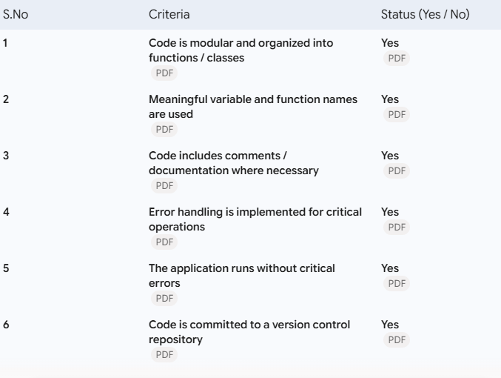

Additional Notes / Comments:
The solution successfully automates the IT procurement lifecycle in ServiceNow. All Flow Designer actions have been tested on a Personal Developer Instance (PDI) with zero execution errors. Low-code Flow Designer blocks are supplemented with clean, commented GlideScript includes for advanced data validation and error handling.

